1. **CRONTAB**

There are no files on Desktop as of now

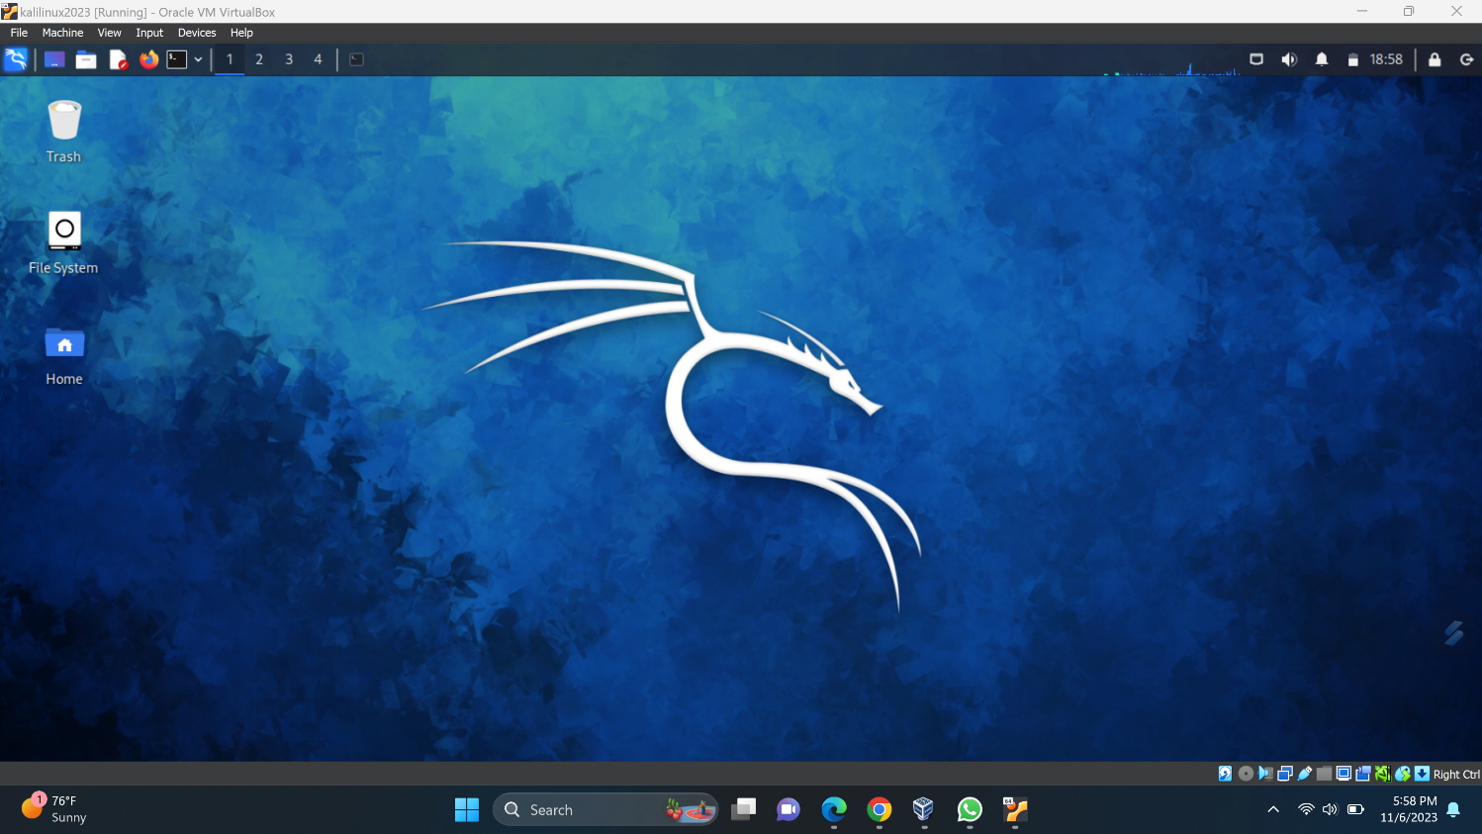

Checking for cronjobs (if any created earlier)

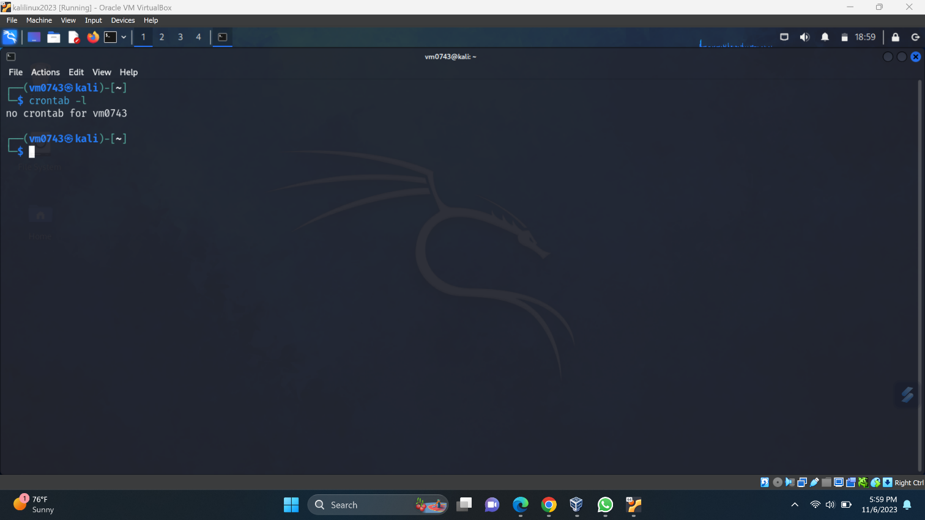

Creating a cronjob

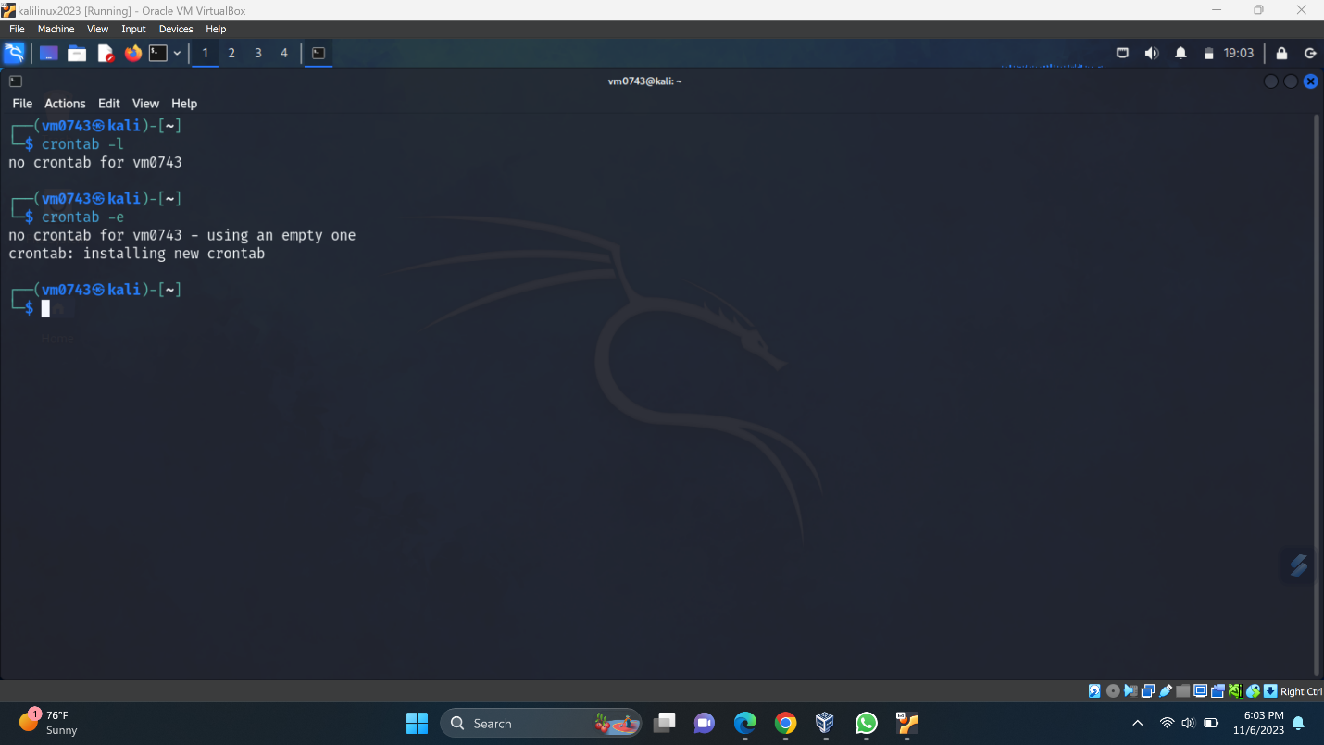

Edit the cronjob file using nano  
* * * * * date >> <path to create the date.txt> I used desktop path to create date.txt

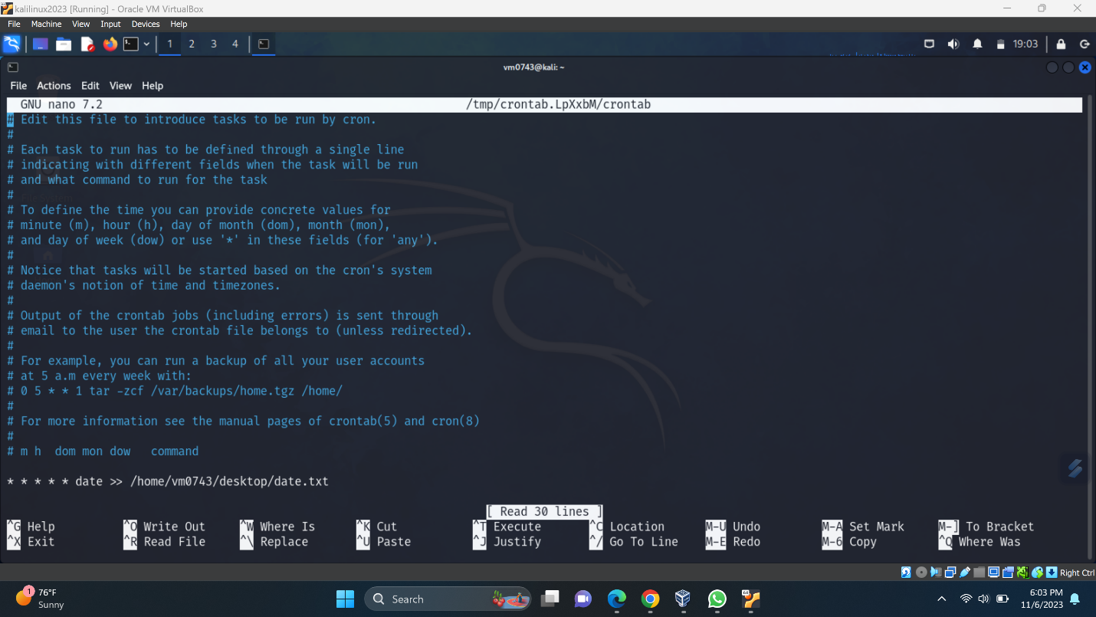

Checking again if the cronjob is saved or not as we can see it is saved and displayed below

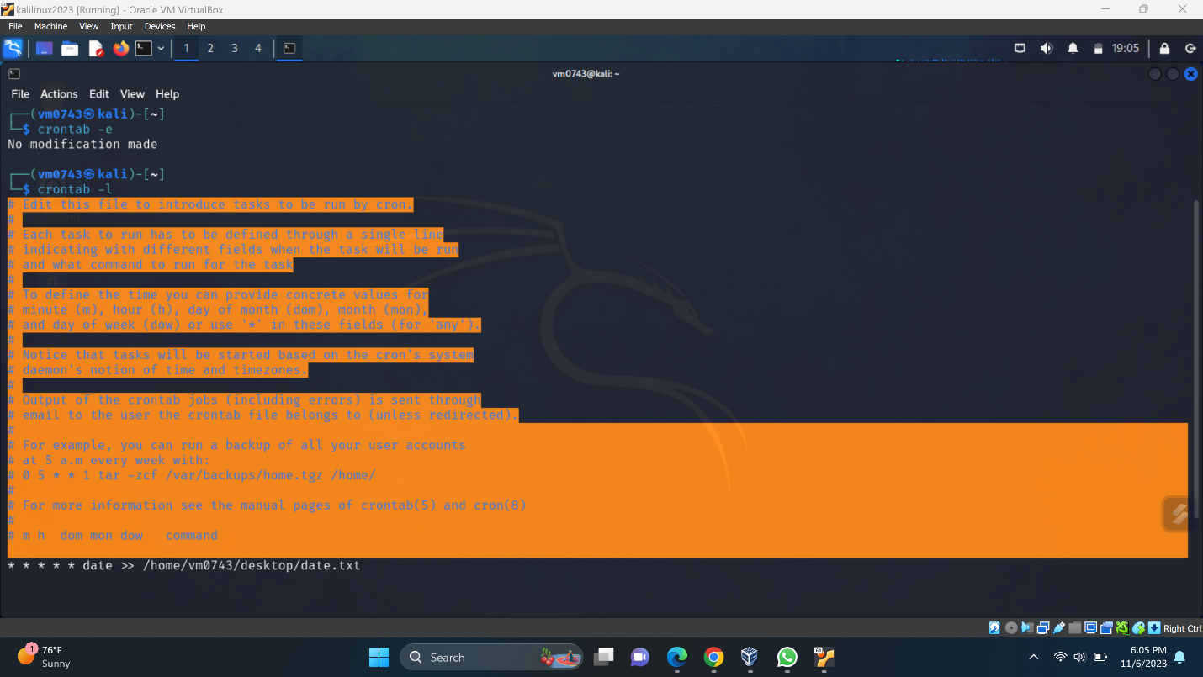

We can see there is a txt file created naming date.txt

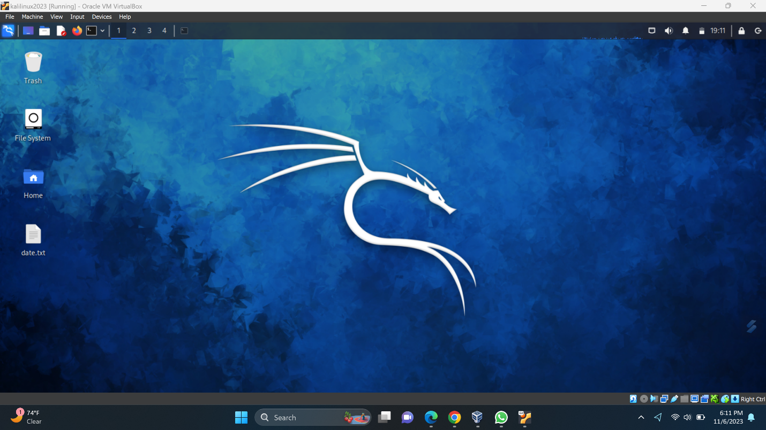

To check if the cronjob is working I changed my directory to desktop and used cat command to check the contents of the date.txt file

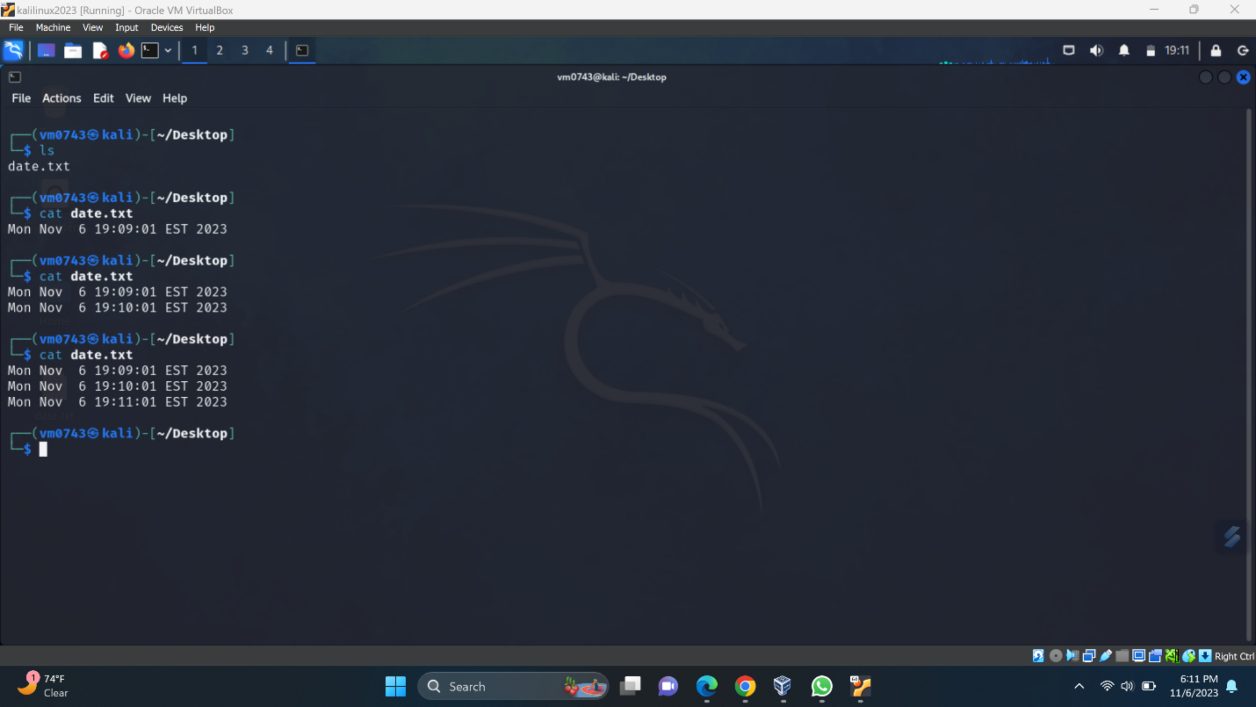

As we can see the date file is getting updated every minute as it was scheduled in the below image

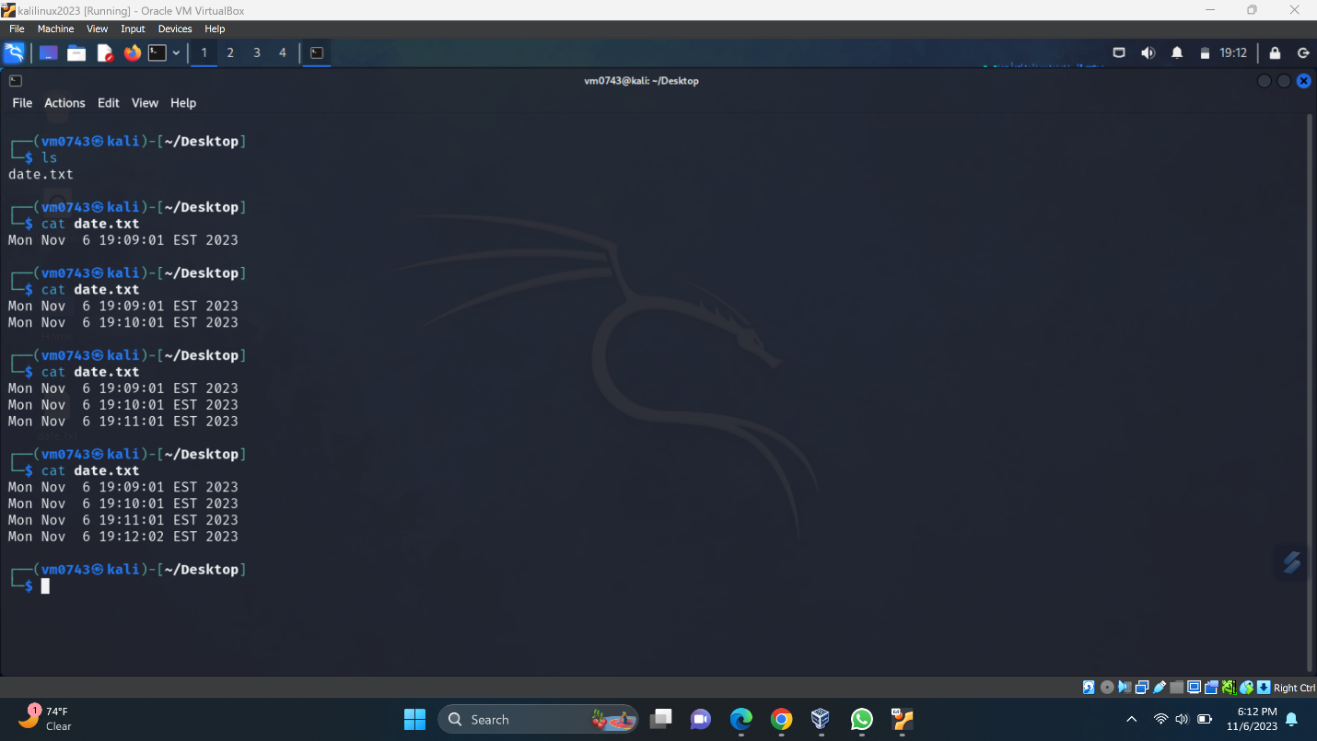

1. SYSTEMD

Lets use systemd to schedule a task to create a date file and print date of that particular minute only.

We can see the desktop is clear and no files are present

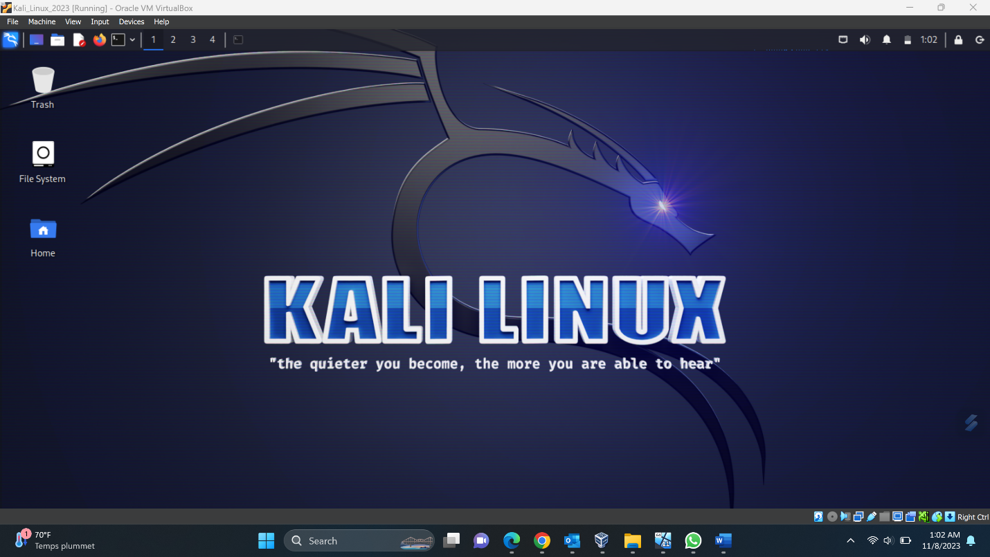

Moving to Desktop folder

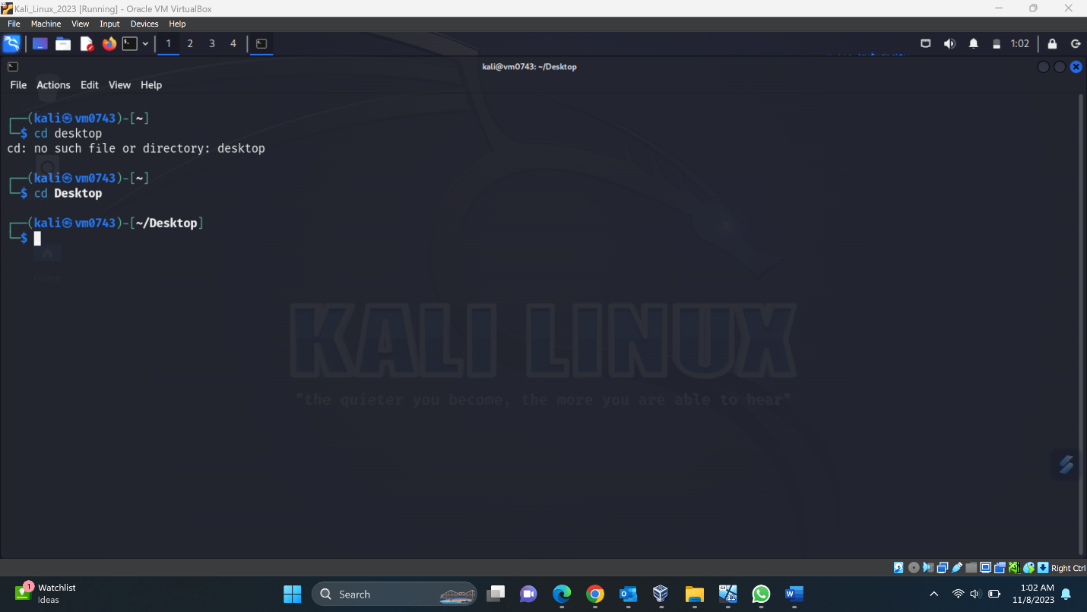

Creating a txt file using touch command named print_time.txt to print the particular minute after we create a systemctl service

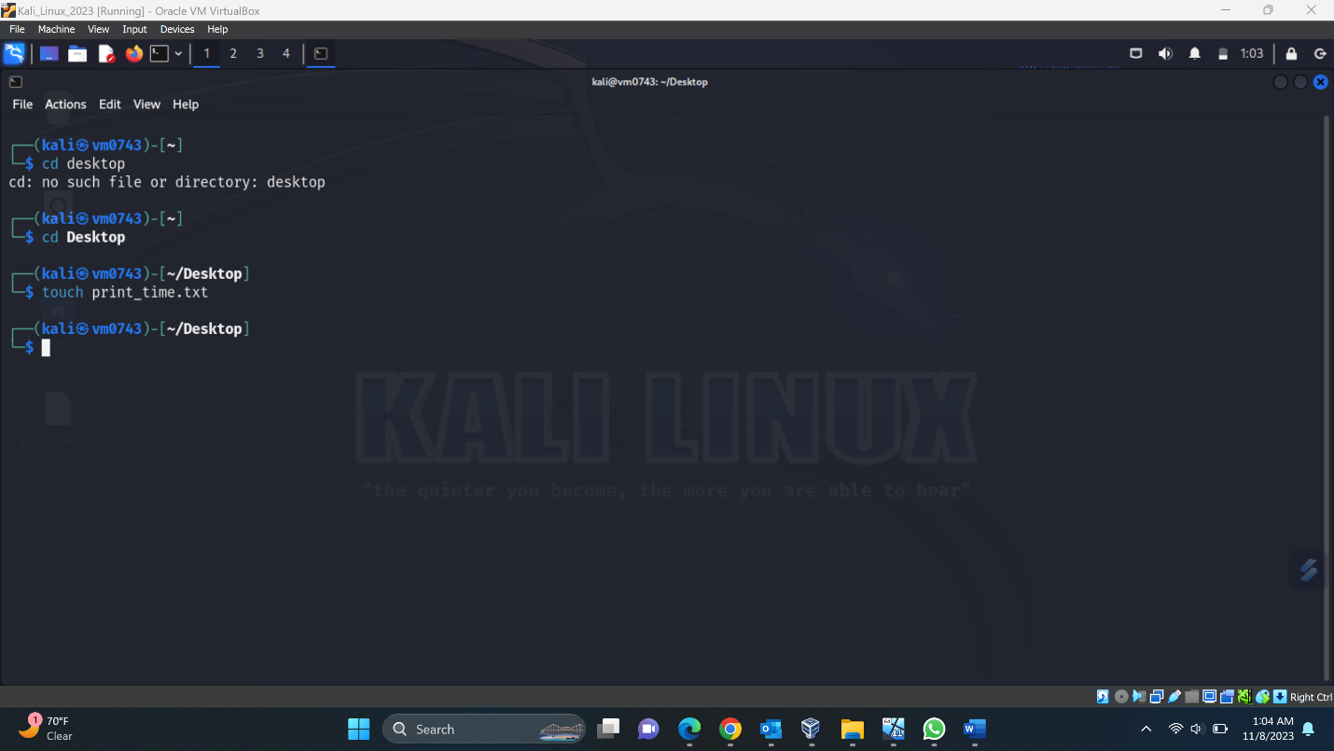

We can see the print_time.txt file created

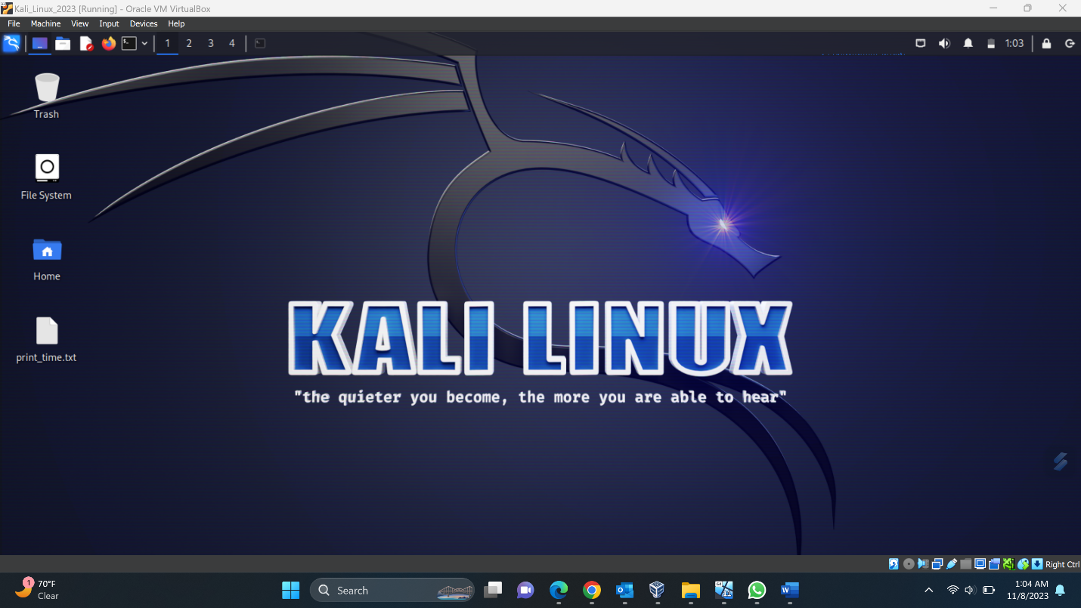

Now we need to create a shell script to run it to print the minute when we run the systemd service, I used nano command to create a shell script so that I can write the script directly when it is created.

Cmd: nano write_time.sh

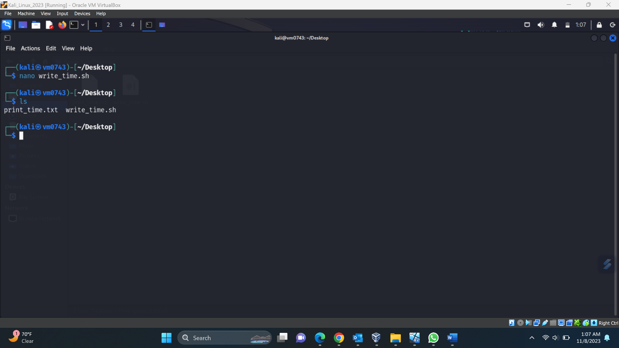

#! /bin/bash

date +”%Y-%m-%d %H:%M:%S” > /path to the file to print the time/ , I used desktop path where I created print_time.txt file and this script will write to the same file

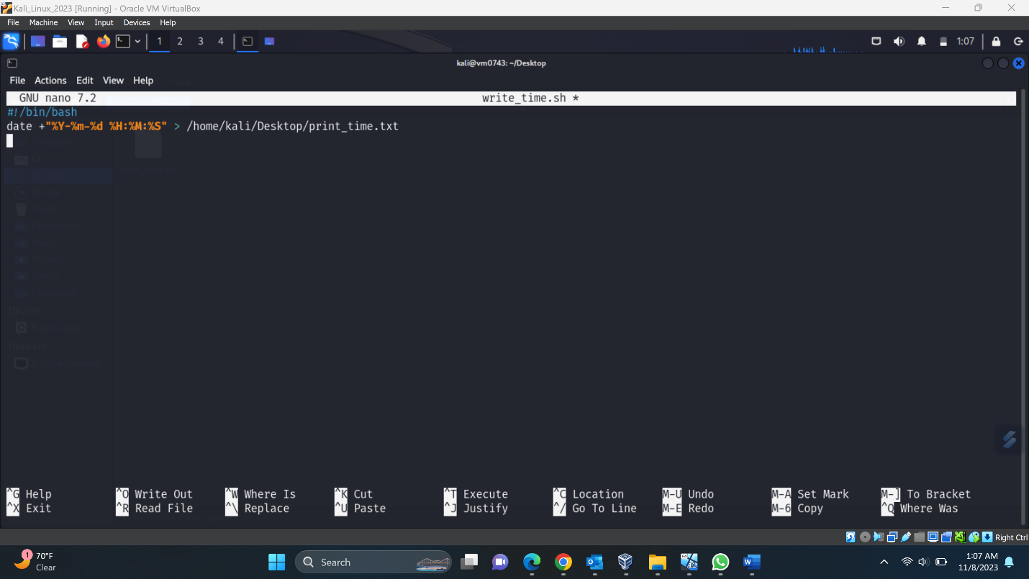

Using ls command to check the files in Desktop folder



Now create a service file using nano command and we need to create it using root privileges hence use: “sudo nano /etc/systemd/system/write-time.service” and used the following contents to create a unit for the service

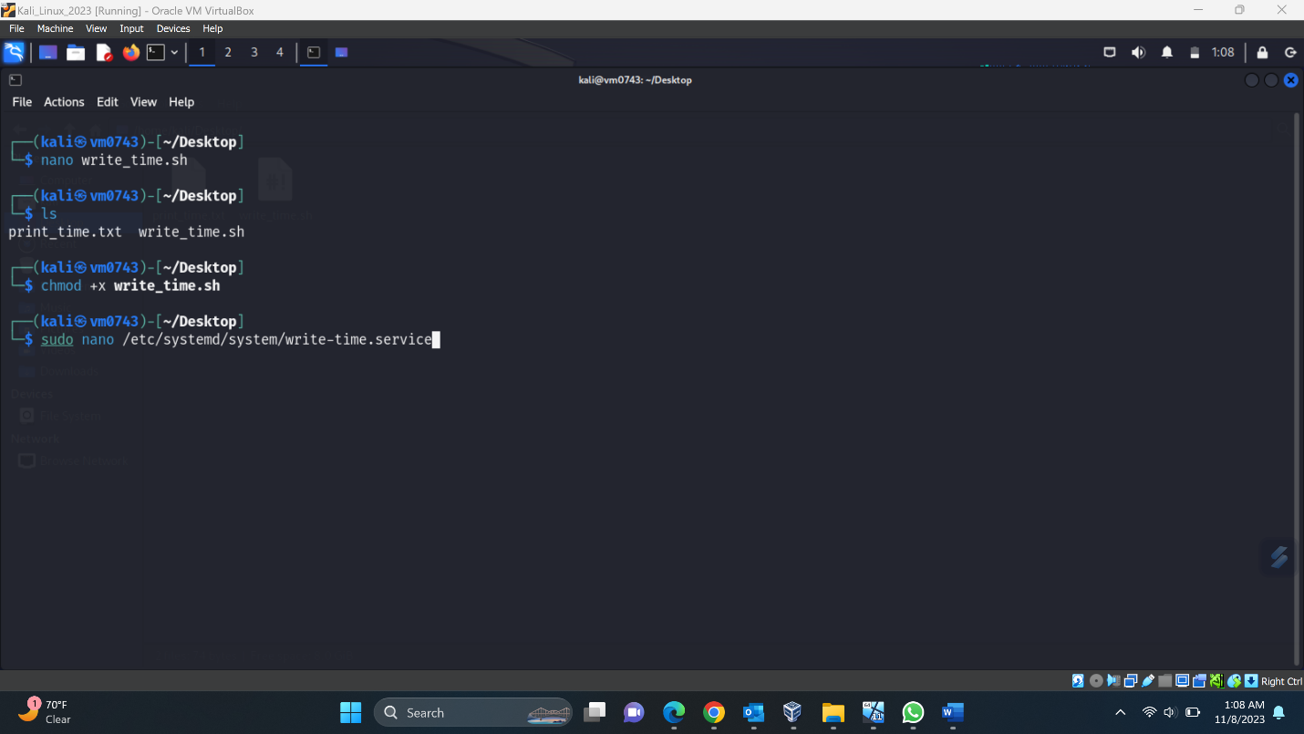

[Unit]  
Description=Write Current Time to Text File

[Service]  
Type=oneshot  
ExecStart=/home/kali/Desktop/write_time.sh

[Install]  
WantedBy=multi-user.target

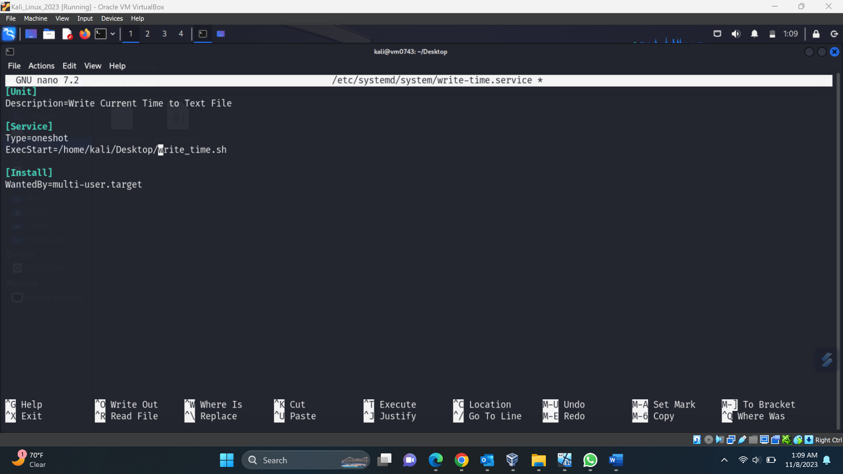

Now let’s create timer file using nano command “sudo nano /etc/systemd/system/write-time.timer”

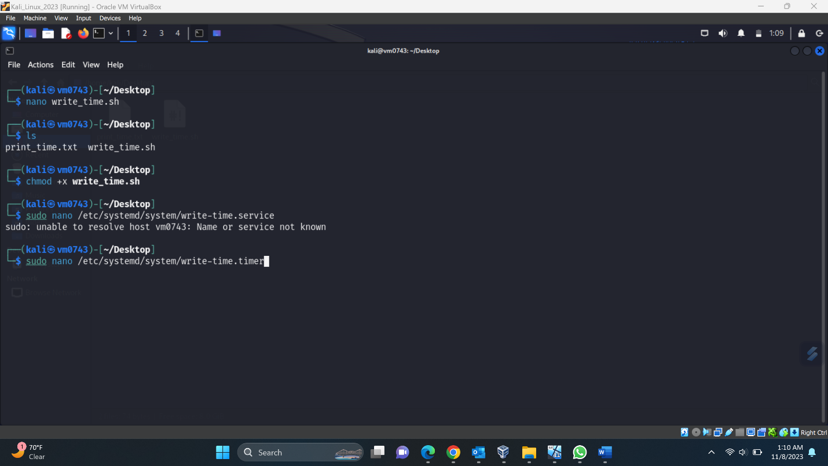

And added the following contents to create a unit for the timer file

[Unit]  
Description=Run Write Time Service

[Timer]  
OnBootSec=1min  
OnUnitActiveSec=1min

[Install]  
WantedBy=timers.target

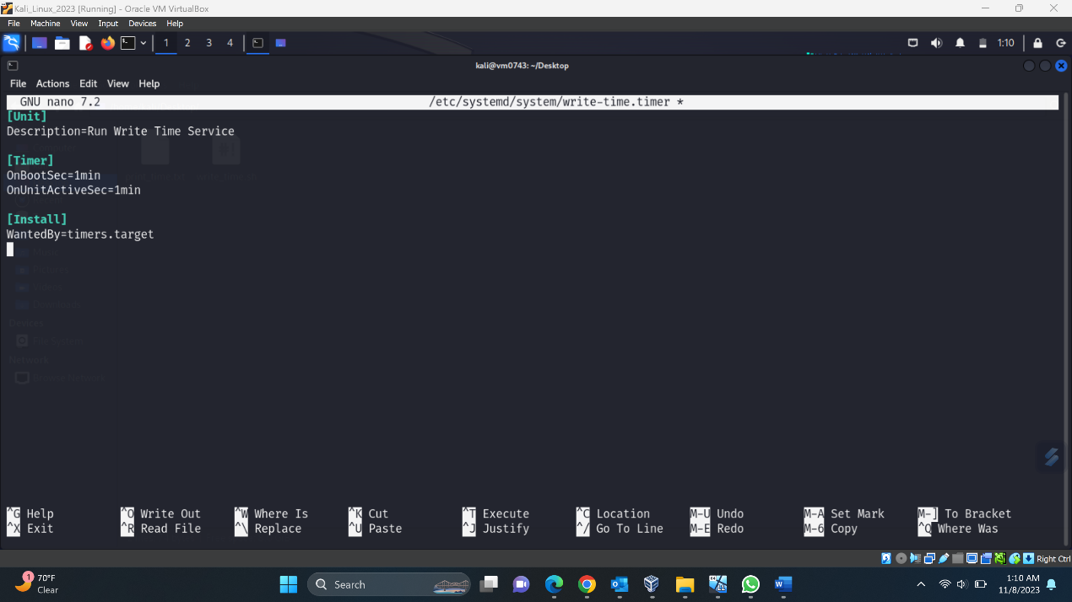

Now we need to enable and start this timer file we created to run a scheduled task using below commands  
sudo systemctl enable write-time.timer  
sudo systemctl start write-time.timer

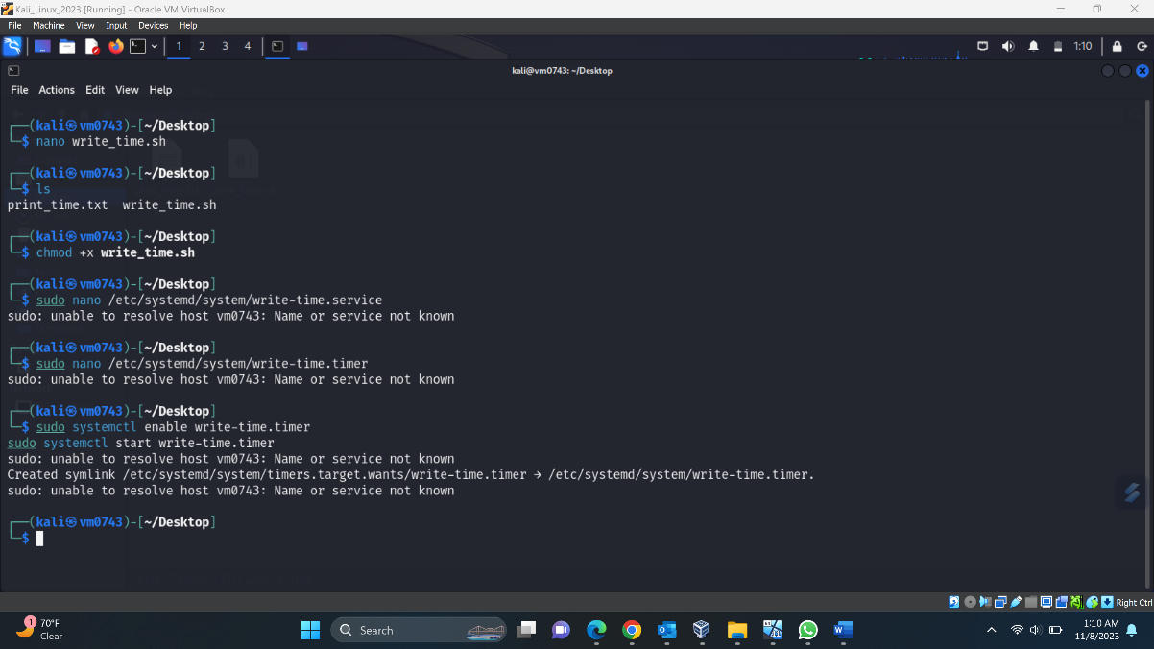

And also we need to enable and start the service file we created to run the scheduled task to print the time to the desktop txt file using below commands

sudo systemctl enable write-time.service  
sudo systemctl start write-time.service

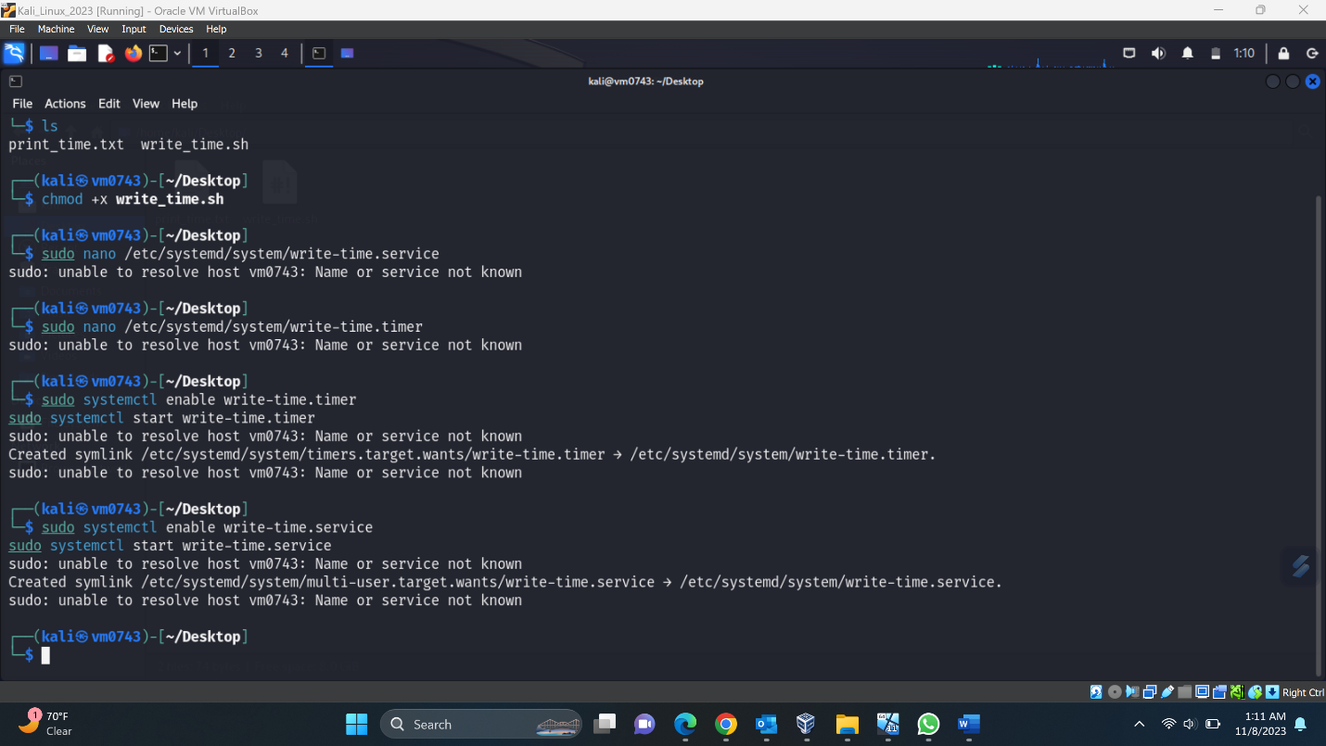

To check the contents of the file, I used cat command to check if the that particular minute is printed or not using this command “cat /home/kali/Desktop/print_time.txt”

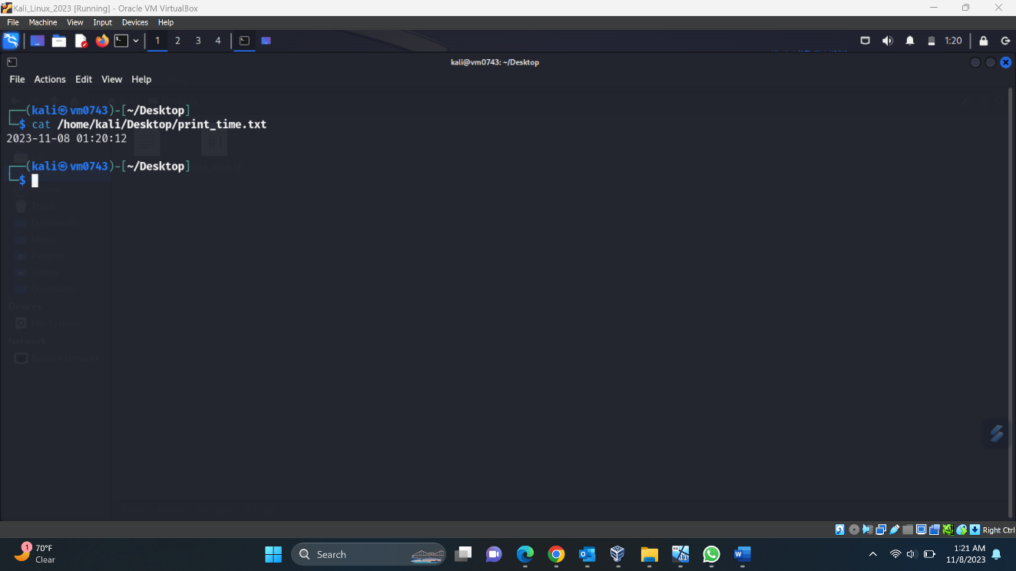

And checked again it is working and it printed 2023-11-08 01:23:12

